Walkthrough Experience Character Outline: Supernatural Menagerie

Character Name: Nox

Description: Nox is a supernatural being, originating back to the Salem Witch Trials, where he took the persona, Reverend Parris. With the sole purpose of haunting mortals, Nox has adopted numerous identities, but he is a boastful spirit, desperate for people to acknowledge his hauntings. With each successful haunting ending in death, he gains control of that spirit.

Happy: Whenever he’s able to haunt people, it brings him immense joy. As people walk through his Supernatural Menagerie, he loves when people appreciate his work and realize he’s responsible for many of the hauntings across America, and successfully trapping guests as his next victims to haunt.

Angry: When guests thwart his plans of deceiving them into becoming his next haunting. Despises guests when they don’t discover his ‘victories’ throughout his time on earth. Angered when guests thwart his attempts to make them his next haunting.

Fear: Nox fears being forgotten and unappreciated for his work. Being despised for his actions is irrelevant, but when he and his work goes unnoticed, he fears his life has been meaningless.

Turn-Ons: Watching his guests discover his origins and his role in the hauntings he’s presenting.

Turn-Offs: Observing his guests learn his true intentions of luring guests to the menagerie.

Reference Photos:
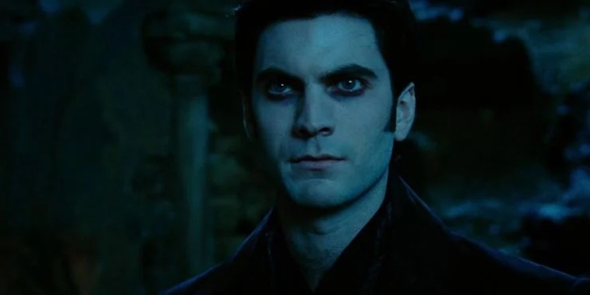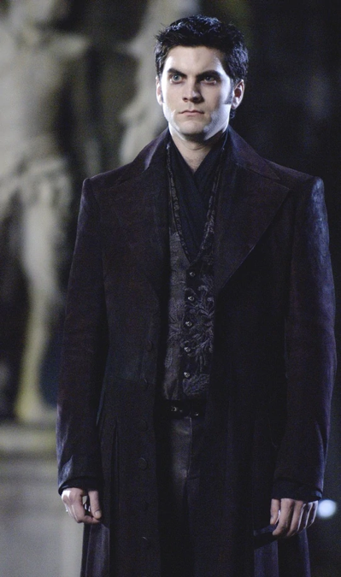
Walkthrough Experience Character Outline: Supernatural Menagerie

Character Name: Captain Kayne

Description: Captain Kayne captained the Queen Mary during World War II, nicknaming the vessel, the Grey Ghost. During his tenure, Kayne transported thousands of soldiers and prisoners of war. During his tenure, Kayne claimed a lady in white haunted him for years until his mysterious death in 1944. As a victim of Nox, he wanders the deck of the Queen Mary, unable to explicitly warn guests of the perils lying before them.

Happy: Whenever he’s able to hint to guests of Nox’s scheme.

Angry: When he sees guests being deceived by Nox. Nox patrolling his ship. His spirit being manipulated to dance and carry out his every wish.

Fear: He fears guests won’t discover Nox’s true intentions and will receive the same sentence dealt to him. Concerning himself, Kayne fears nothing. No punishment is worse than the one he’s been dealt.

Turn-Ons: Watching guests piece together the truth of Nox’s treachery.

Turn-Offs: Nox using his ability to control his victims and making them perform for his guests.

Reference Photos:

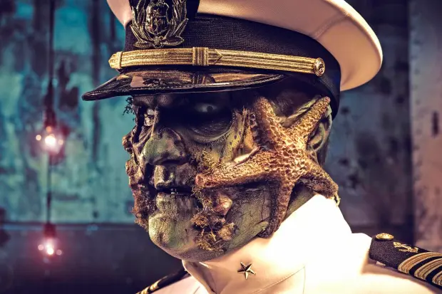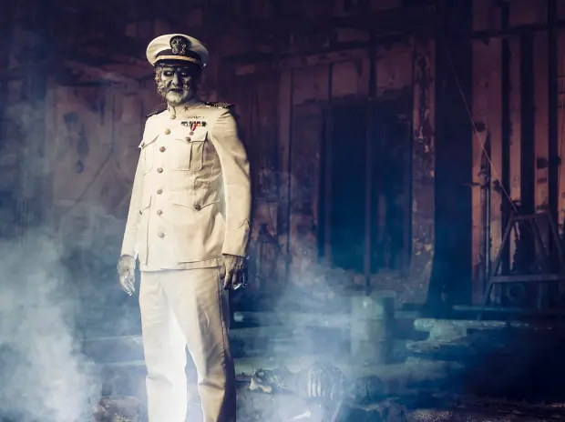
Walkthrough Experience Character Outline: Supernatural Menagerie

Character Name: The Lady in White

Description: The Lady in White is Nox’s persona while aboard the Queen Mary. Shrouded in all white, with only her smile visible, she stalks the ship and haunts those she deems weak-hearted. In the ballroom, she’s gathered all her haunted victims, allowing them to speak to her guests, but forbidding them from informing guests of her true intentions. When interacting with guests, she’s calm and collected and uses few words. She’s unaware of the spirits hinting to the menagerie’s true purpose of luring guests to become Nox’s next haunting. If she needs to be entertained, she walks to the center of the room and raises her hand, making the spirits perform a waltz.

Happy: She’s happy while manipulating the movements of the spirits and misleading guests. She becomes ecstatic when guests talk about the history of the ship and its many hauntings.

Angry: The Lady in White isn’t angered by anything.

Fear: The Lady in White fears nothing, believing nothing can, or will go wrong.

Turn-Ons: Watching guests interact with the spirits and learn. When guests approach her

Turn-Offs: Guests not paying her or the exhibits any attention.

Reference Photos:
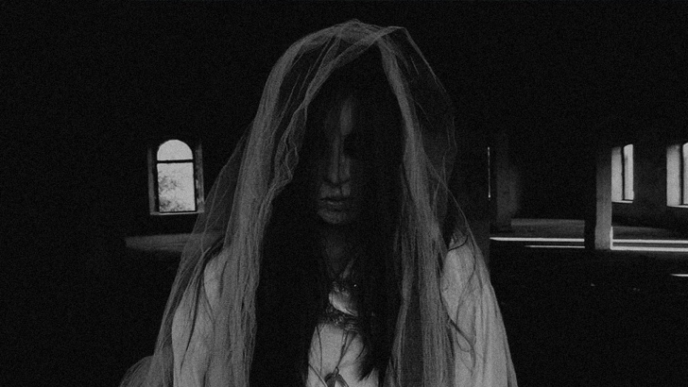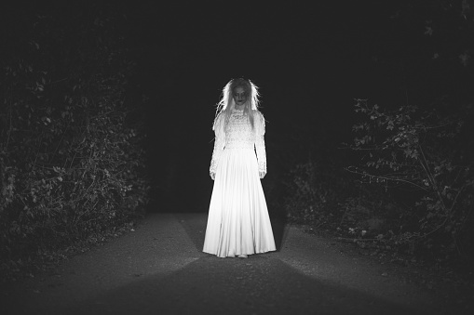
Walkthrough Experience Character Outline: Supernatural Menagerie

Character Name: Sarah Winchester

Description: Sarah Winchester is the owner of the Winchester House, living there for over 50 years. Sarah is Nox’s biggest failure, never being able to haunt her, due to Sarah constructing her house as a confusing maze. Nox has never been able to find Sarah. Instead of passing on into the afterlife, Sarah has remained behind to warn guests of Nox, revealing his intentions, and urging them to leave before it’s too late.

Happy: She’s happy while manipulating the movements of the spirits and misleading guests. She becomes ecstatic when guests talk about the history of the ship and its many hauntings.

Angry: Sarah isn’t angered by anything.

Fear: Sarah fears her warnings won’t be heeded, and guests will fall into Nox’s traps. She fears Nox will discover how to navigate the house, find her, and seize her spirit.

Turn-Ons: Warning guests and watching them successfully navigate the house to escape.

Turn-Offs: Guests not heeding her warnings.

Reference Photos:
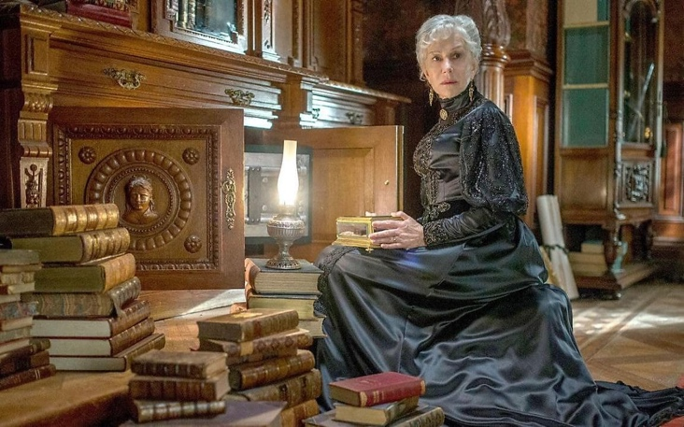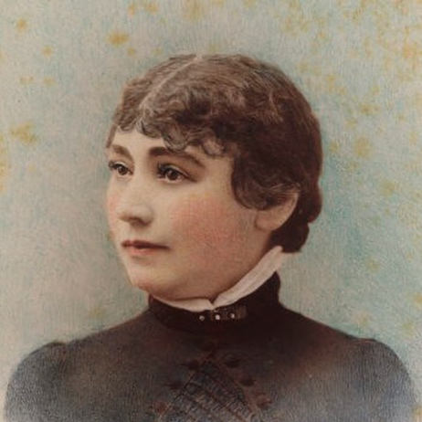

Walkthrough Experience Character Outline: Supernatural Menagerie

Character Name: Warden Herbert ‘Hardboiled’ Smith

Description: Nox’s persona within the Eastern State Penitentiary. Normally he materializes as a spirit or an object, but here he disguised himself as person. Patrolling the wards for nearly ten years, he tortured prisoners with manmade devices and drove them insane.

Happy: He’s happy when torturing prisoners and watching them slowly lose their minds to insanity. Seeing people wander into the cells, looking at the exhibits.

Angry: The Warden becomes angered when he realizes guests discover the mirror to his realm.

Fear: He fears people will discover his office and the mirror leading to his lair, but his fear isn’t clearly shown. His voice and mannerisms hint at his fear.

Turn-Ons: Watching Al Capone mutter to himself and showcase his insanity to guests. Seeing the guests’ shocked faces when they discover his malicious acts.

Turn-Offs: Guests not learning from the exhibits or being appreciated for all his hard work.

Reference Photos:
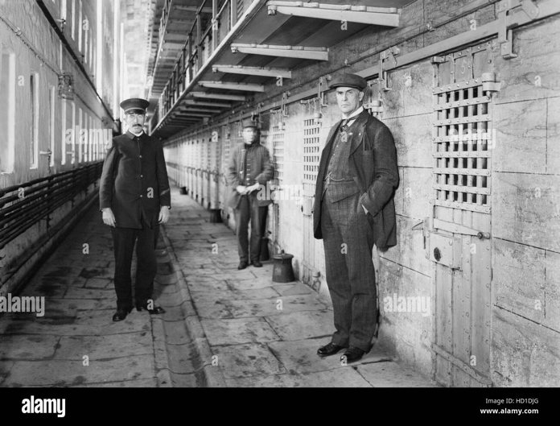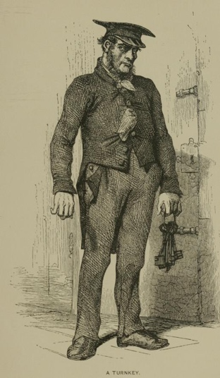
Walkthrough Experience Character Outline: Supernatural Menagerie

Character Name: Al Capone

Description: While Al Capone didn’t die in the Eastern State Penitentiary, he was a prime target of Warden Smith (Nox). Nox loved haunting Capone so much, he snagged Capone’s spirit and trapped him within his old cell. Capone is suspicious of the Warden but doesn’t know he’s an otherworldly being. He rambles how he hears voices and sees shadows move on the wall. He even hears and sees a man he killed on St. Valentine’s Day Massacre, James Clark. He believes the warden is hiding something in his office, noticing he spends hours to days in there at a time.

Happy: Capone is happy to have company he can talk too and that’s his cell is comprised of his valued objects.

Angry: Capone doesn’t express anger.

Fear: He fears his ‘sentence’ will never end and be forever locked behind bars.

Turn-Ons: People coming up and talking to him and passing on his words of wisdom as a crime boss. Loves to regale about his time in Chicago.

Turn-Offs: Guests being rude, dismissive, and making fun of him for being caught for tax evasion.

Reference Photos:
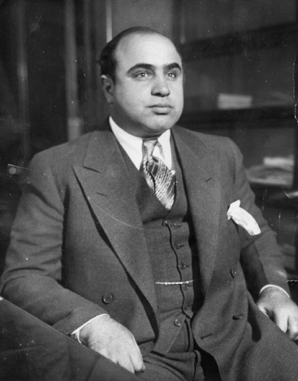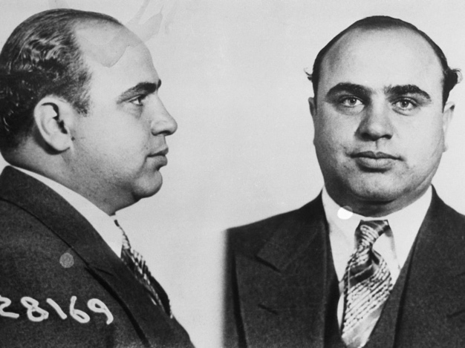
Walkthrough Experience Character Outline: Supernatural Menagerie

Character Name: Nox’s True Form

Description: When guests discover Nox’s true intentions, he no longer feels the need to hide his true form. While he took on the persona of Reverend Parris during the Salem Witch Trials, his true form is an otherworldly demon. His benevolent ruse is gone, Nox shows he’s a malicious individual. With guests knowing his true intentions, he lets them go, but warns their treachery will not go unpunished.

Happy: Nox does not feel happiness in this form.

Angry: Despises guests for discovering why he opened his Supernatural Menagerie.

Fear: With these guests discovering his intentions, he fears more guests will uncover the truth as well, and will never haunt another individual again.

Turn-Ons: Watching fear creep into the guests’ eyes after he delivers his warning. Guests knowing who he is and the hauntings he’s performed.

Turn-Offs: When guests brush off his warning and don’t take him seriously.

Reference Photos:
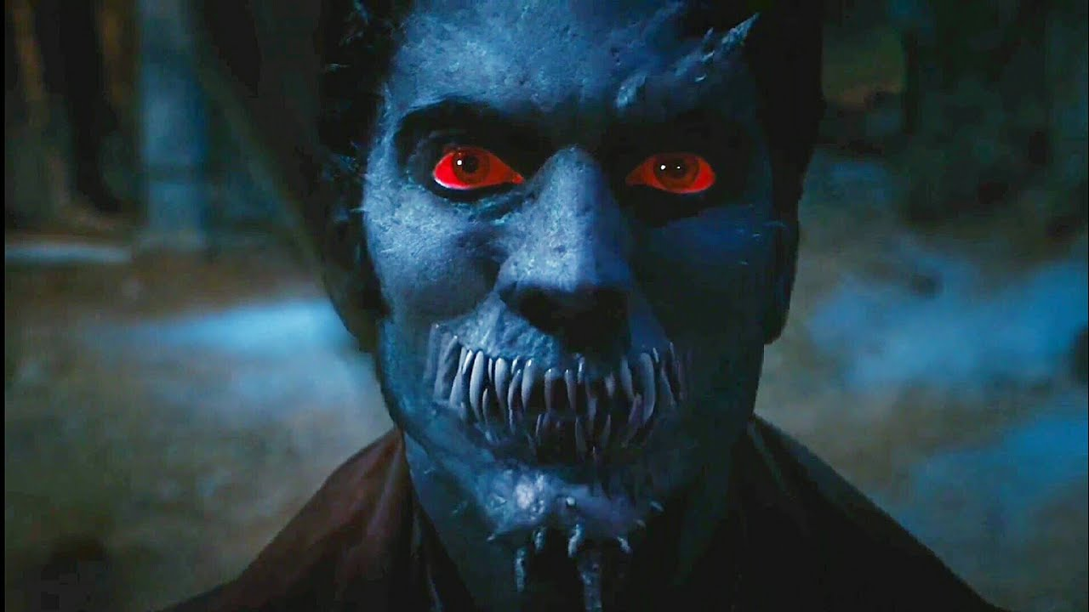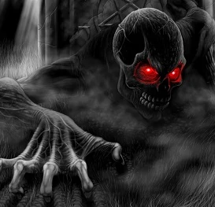
Character: Dancer Spirits (M+F)

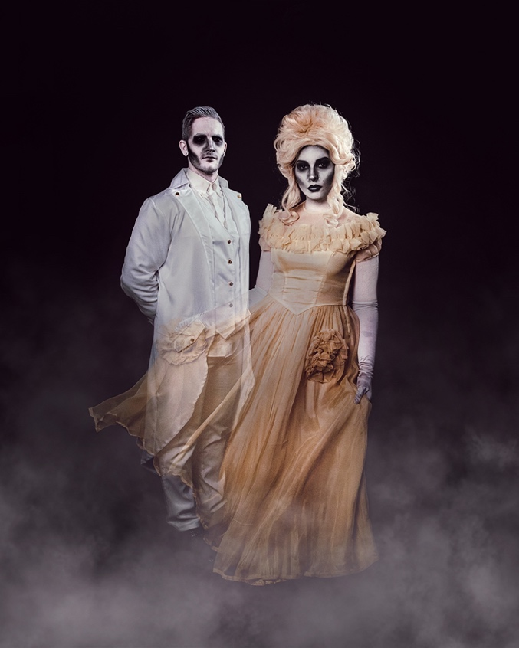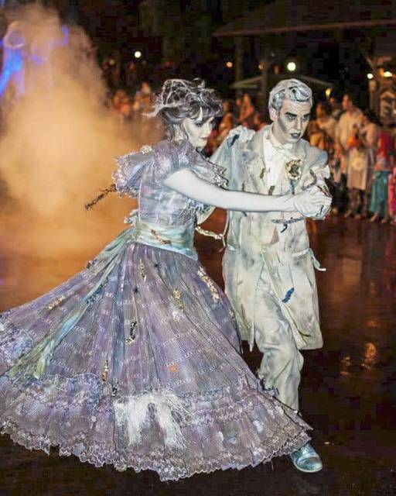

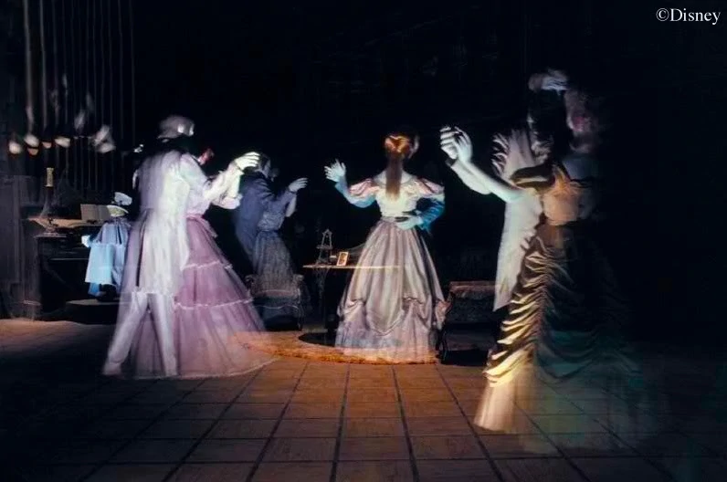
Character: | Dancer Spirits (M+F)
Handheld Props: | N/A
Location: | Queen Mary, Ballroom
Mask/Make-up: | Faces painted white, eye sockets and face look sunken
Wardrobe: | Women’s wardrobe includes elaborate dresses, maid dress ware and 1920s swimwear. Men’s wardrobe includes military garments, tuxedos, and engine room workers.
Character Backstory: | Each spirit was haunted by Nox (the Lady in White) and died abroad the Queen Mary. Since they were haunted by Nox, their spirit remains on the Queen Mary under his control.
Character Wants: | They want to warn guests of Nox’s true reasoning for bringing guests, but they can’t explicitly do so.
Idle Actions: | Being friendly as guests enter the ballroom, but when guests engage in conversation, they urge them to escape.

